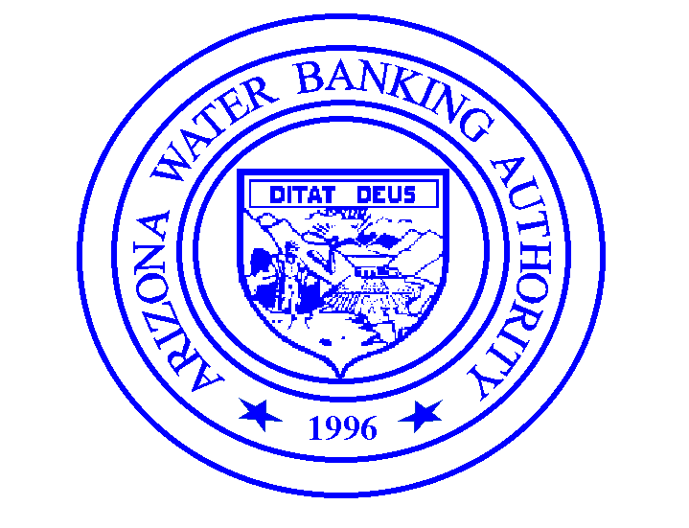
AUTHORITY MEMBERS
Thomas Buschatzke, Chairman
Maureen R. George, Vice-Chairman
Clifford A. Neal, Secretary
Jim Hartdegen
John Mawhinney

EX OFFICIO MEMBERS
The Honorable David M. Gowen, Sr.
The Honorable Gail Griffin

Arizona Water Banking Authority
3550 N. Central Avenue, Phoenix, Arizona 85012
Telephone 602-771-8487
Fax 602-771-8686

DATE

Governor Stephen Roe Lewis
Linus Everling, General Counsel
Gila River Indian Community
525 West Gu u Ki
P.O. Box 97
Sacaton, AZ 85247

Re: Agreement between the Arizona Water Banking Authority and the Gila River Indian Community for Payment of Water Deliveries

Dear Governor Lewis and Mr. Everling:

On _____________, 2015, the Arizona Water Banking Authority (AWBA) and the Gila River Indian Community (Community) entered into an intergovernmental agreement (IGA) that establishes an annual process to insure that the obligations of the State set forth in Section 105(b)(2)(A) of the Arizona Water Settlements Act (Pub. L. No. 108-451) are satisfied. Exhibit B to the IGA identifies several methods that may be implemented to satisfy a firming requirement.

Method No. 4 of Exhibit B allows the AWBA to accrue “firming credits” through payment for water delivered to the Community during non-shortage years. Firming credits that are registered to a “Firming Account” held by the AWBA may be debited in the future, in accordance with the provisions of the IGA, to reduce the State’s firming obligation on an acre-foot per acre-foot basis.

To facilitate the establishment of the Firming Account, the AWBA proposes that the Community amend its 2015 payment schedule with the Secretary of the Interior to pay the full cost for up to 16,000 acre-feet of Central Arizona Project (CAP) water ordered for delivery to the Community this year. Pursuant to the CAP Final 2015-2016 Rate Schedule, the water delivery rate for Federal customers for 2015 is $157 per acre-foot. The AWBA will agree to reimburse the Community for each acre-foot of CAP water delivered to the Community at full cost not to exceed $2,512,000.00 ($157 x 16,000 acre-feet). The AWBA will in-turn register the equivalent amount of firming credits (16,000 acre-feet) to the Firming Account.

If the terms of this proposal are acceptable to the Community, please sign this letter and return it to the AWBA for AWBA Commission action. Upon final execution by the AWBA Commission, we will return one original for your files.

If you have any questions, please contact me at (602) 771-8491.

Sincerely,

Virginia O’Connell
Manager

ACCEPTED AND AGREED TO:

GILA RIVER INDIAN COMMUNITY

By: ______________________________
Governor

ARIZONA WATER BANKING AUTHORITY

By: ______________________________
Chair

